### **Random Forest**

**1. Definition & Core Concept**

* **What it is:** Random Forest is a versatile and widely used *supervised machine learning algorithm*. It belongs to the family of *ensemble methods*.
* **Ensemble Type:** It's fundamentally an extension of **Bagging (Bootstrap Aggregating)** applied specifically to **Decision Trees**.
* **Mechanism:** It constructs a multitude (a "forest") of decision trees during the training phase and outputs the class that is the *mode* of the classes (classification) or the *mean/average* prediction (regression) of the individual trees.
* **Goal:** To improve the predictive accuracy and stability (reduce variance) compared to a single decision tree, and to reduce the risk of overfitting.

**2. How Random Forest Works**

The algorithm combines two key ideas: **Bagging** and **Feature Randomness**.

1. **Bootstrap Sampling (Bagging):**
   * From the original training dataset of size N, create *multiple* (equal to the number of trees you want to build, n_estimators) new training datasets (bootstrap samples).
   * Each bootstrap sample is created by randomly drawing N samples *with replacement* from the original dataset. This means some data points might appear multiple times in a sample, while others might be left out (these are called Out-Of-Bag samples).
2. **Random Feature Selection (Feature Randomness):**
   * Train an individual decision tree on each bootstrap sample.
   * **Crucially:** When deciding on the best split at each node of a tree, *do not* consider all available features. Instead, randomly select a *subset* of features (max_features).
   * Find the best split *only among this random subset of features*.
   * This step ensures that the trees in the forest are *decorrelated* (less similar to each other), which is key to the algorithm's effectiveness.
3. **Tree Growth:**
   * Grow each decision tree fully (usually without pruning, though parameters like max_depth, min_samples_split, min_samples_leaf can control complexity).
4. **Aggregation (Voting/Averaging):**
   * To make a prediction for a new data point, pass it down *every* tree in the forest.
   * **Classification:** Collect the predictions (votes) from all trees and choose the class with the *majority vote* as the final prediction.
   * **Regression:** Collect the predictions (continuous values) from all trees and take the *average* as the final prediction.

**3. Key Features & Concepts**

* **Ensemble of Decision Trees:** Leverages the power of multiple models.
* **Bagging:** Reduces variance by training on different data subsets.
* **Feature Randomness (Random Subspace Method):** Reduces correlation between trees, further improving generalization.

**4. Advantages**

* **High Accuracy:** Often provides very good predictive performance with relatively little hyperparameter tuning.
* **Robustness to Overfitting:** Combining many trees and using feature randomness significantly reduces the risk of overfitting compared to a single deep decision tree.
* **Handles High Dimensionality:** Works well even with datasets having a large number of features.
* **Handles Missing Values:** Can handle missing data reasonably well (some implementations impute missing values or learn pathways around them). No need for extensive data pre-processing like feature scaling (normalization/standardization).
* **Handles Non-Linearity:** Capable of capturing complex, non-linear relationships between features and the target.
* **Feature Importance Estimation:** Can provide estimates of how important each feature is for the prediction (e.g., using Gini importance or permutation importance). This helps in feature selection and understanding the data.
* **Parallelizable:** Trees can be trained independently and in parallel, speeding up the training process on multi-core systems.

**5. Disadvantages**

* **Less Interpretable ("Black Box"):** While we can estimate feature importance, understanding the exact reasoning behind a specific prediction from the entire forest is difficult compared to a single decision tree or a linear model.
* **Computationally Intensive:** Training many trees can be computationally expensive and require more memory, especially for very large datasets or a large number of trees.
* **Prediction Time:** Can be slower at prediction time than simpler models, as input needs to be passed through every tree.
* **May Not Perform Well on Very Sparse Data:** Linear models might be more suitable for very high-dimensional, sparse data (like text).
* **Can Still Overfit on Noisy Data:** While robust, it can sometimes overfit if the data is particularly noisy and trees are grown very deep without constraints.

**6. Important Hyperparameters**

* n_estimators: The number of trees in the forest. More trees generally improve performance up to a point but increase computational cost.
* max_features: The number (or fraction) of features to consider when looking for the best split at each node. A common starting point is sqrt(n_features) for classification and n_features / 3 for regression.
* max_depth: The maximum depth allowed for each tree. Controls tree complexity.
* min_samples_split: The minimum number of samples required to split an internal node.
* min_samples_leaf: The minimum number of samples required to be at a leaf node.
* criterion: The function to measure the quality of a split ('gini' or 'entropy' for classification, 'squared_error' or 'absolute_error' for regression).
* oob_score: Whether to use out-of-bag samples to estimate the generalization score.

**7. Common Applications**

Random Forest is used across many domains:

* **Finance:** Credit risk assessment, fraud detection, stock market prediction.
* **Healthcare:** Disease diagnosis, patient outcome prediction, drug response modeling.
* **E-commerce:** Customer churn prediction, recommendation systems.
* **Ecology/Remote Sensing:** Land cover classification.
* **Image Recognition:** Object detection and classification tasks.

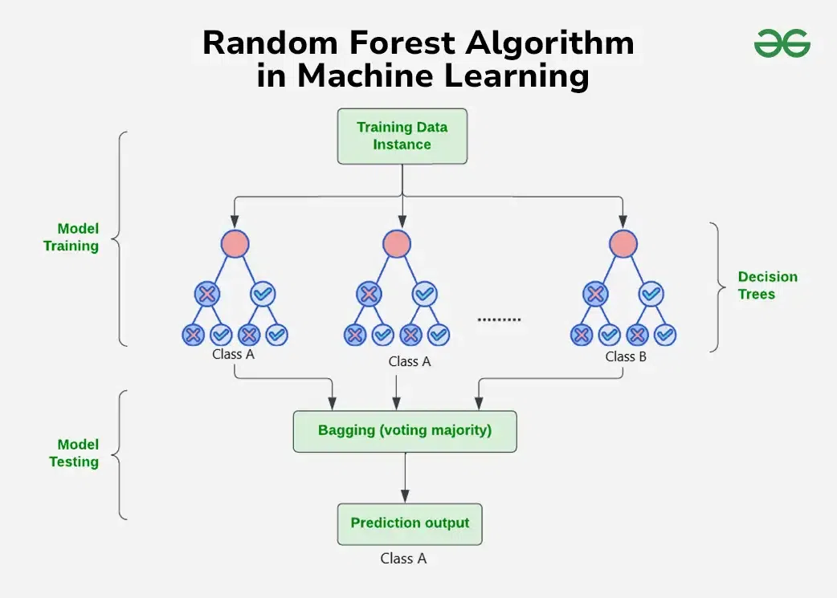

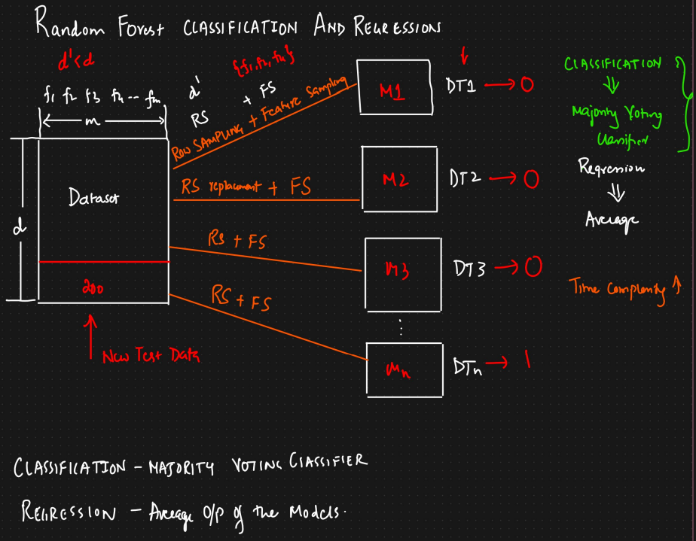

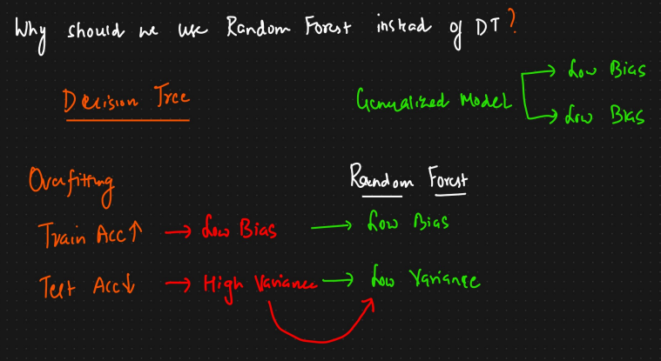

1. **What are Out-of-Bag (OOB) Samples?**
   * When building a Random Forest, each individual decision tree is trained on a *bootstrap sample* drawn from the original training data (sampling with replacement).
   * Because of the "with replacement" sampling, some data points from the original dataset will be left out of any specific bootstrap sample.
   * For a given tree, the data points *not* included in its bootstrap sample are called its "Out-of-Bag" (OOB) samples. On average, about one-third (roughly 36.8%) of the original data points are OOB for any given tree.
2. **What is OOB Error (or OOB Score)?**
   * The OOB error is a way to measure the prediction error (estimate the performance) of the Random Forest model *using only the training data*.
   * It leverages the OOB samples as a sort of internal validation set.
3. **How is OOB Error Calculated?**
   * For **each data point** in the original training set:
     + Identify all the trees in the forest for which this data point was **out-of-bag** (i.e., the trees that were *not* trained using this specific data point).
     + Make a prediction for this data point using *only* that subset of trees (e.g., by taking a majority vote for classification or averaging for regression).
     + Compare this prediction to the data point's true label/value.
   * The OOB error is the overall error rate (e.g., misclassification rate for classification or mean squared error for regression) calculated by aggregating the errors across all data points evaluated this way.
   * The OOB Score is often calculated as 1 - OOB Error (representing accuracy for classification).
4. **Why is OOB Error Useful?**
   * **Internal Validation:** It provides an estimate of how well the model generalizes to unseen data *without* needing to set aside a separate validation or test set. This is useful when data is limited.
   * **Computational Efficiency:** It's often less computationally expensive than techniques like k-fold cross-validation, as the error is calculated during the training process itself.
   * **Less Biased Estimate:** It's generally considered a reasonably unbiased estimate of the test set error, often similar to leave-one-out cross-validation. (Though some studies suggest it might slightly overestimate the error in certain specific situations).
   * **Model Tuning:** The OOB error can be monitored as more trees are added to the forest, helping to determine an adequate number of trees (n_estimators) where the error stabilizes.

